Lab 9 Report
The purpose of this lab is to solidify you to the usage of some important lab equipments. This lab will allow you to learn about capacitors, AC voltage source, a breadboard, a multimeter.

Useful Equations

Experiment 1 – Full Bridge Rectifier
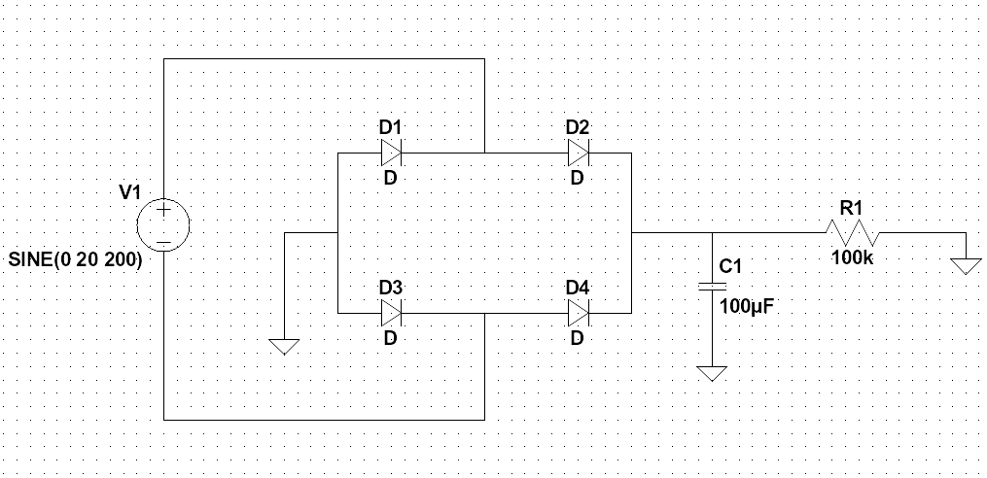Figure 1: Circuit diagram of Experiment 1.

Components and Instruments used:
- A computer: used in the pre-lab to get experiment details from the Moodle
- Resistor kit: contains the resistors to create circuits in the breadboard
- Tektronix PS280 power supply: voltage source
- Fluke multimeter: used to get measurements such as potential difference, current, etc.
- Breadboard: used to create circuits and connect wires to find values

Procedure:
- Create the circuit shown in Figure 1 on breadboard using the shown resistor values.
- Connect the power supply and change it according to the tables below.
- Set the multimeter to voltage measurement mode and for each resistor, connect the multimeter as parallel to the resistors and measure the voltage drops.
- Set the multimeter to current measurement mode and for each resistor, connect the multimeter as series before or after to the resistor that you want to measure the current passing through.

Results
RESULTS WITHOUT UNITS WILL NOT BE GRADED!
Table 1: Voltage measurements.
A | B | Out
0 | 0
0 | 1
1 | 0
1 | 1

Experiment 2 – Low Pass Filter
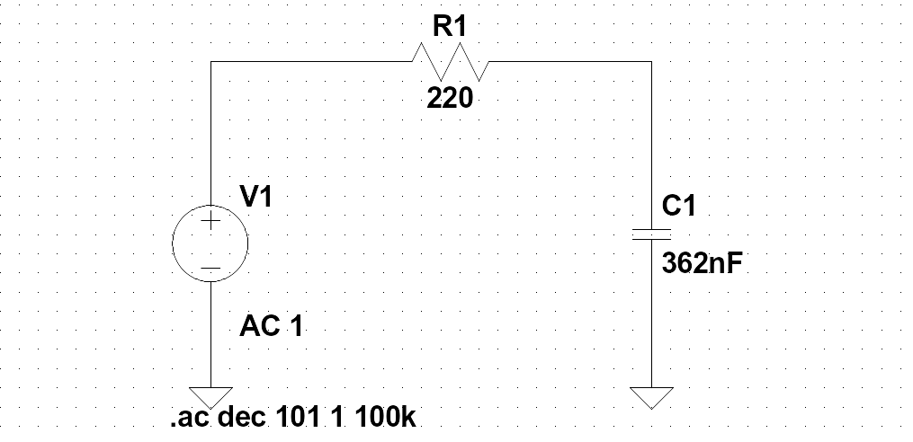Figure 2: Circuit diagram of Experiment 2.

Components and Instruments used:
- A computer: used in the pre-lab to get experiment details from the Moodle
- Resistor kit: contains the resistors to create circuits in the breadboard
- Tektronix PS280 power supply: current source
- Fluke multimeter: used to get measurements such as potential difference, current, etc.
- Breadboard: used to create circuits and connect wires to find values

Procedure:
- Create the circuit shown in Figure 2 on breadboard using the shown resistor values.
- Connect the power supply in constant voltage mode and set the voltage to 9V.
- Set the multimeter to voltage measurement mode and for each resistor, connect the multimeter as parallel to the resistors and measure the voltage drops.
- Set the multimeter to current measurement mode and for each resistor, connect the multimeter as series before or after to the resistor that you want to measure the current passing through.
- Compare the resistor ratios R1, R2, and R3 to potential difference over load R4 and R5. Verify that the potential difference over R3 and 9V is proportional to the R2 and R1.

Results
RESULTS WITHOUT UNITS WILL NOT BE GRADED!
Table 2: Voltage measurements.
A | B | Out
0 | 0
0 | 1
1 | 0
1 | 1

Experiment 3 – High Pass Filter
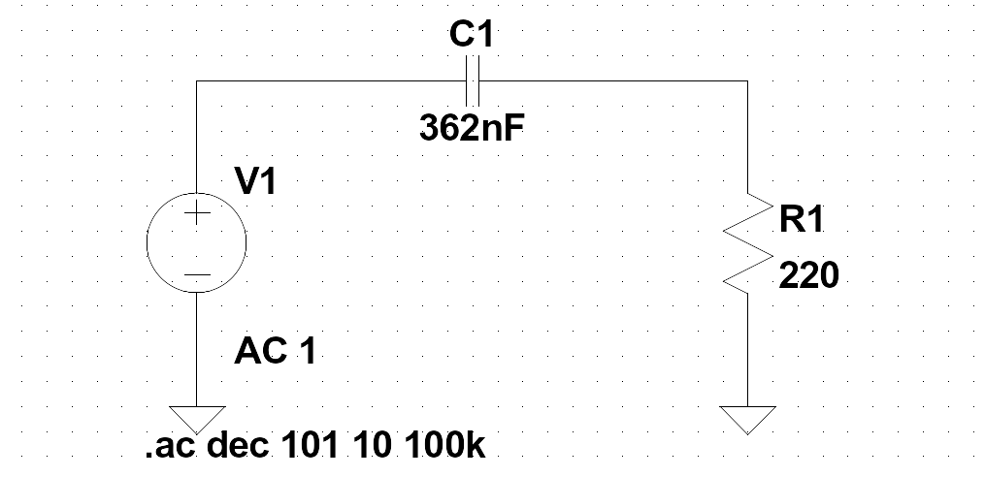Figure 3: Circuit diagram of Experiment 2.

Components and Instruments used:
- A computer: used in the pre-lab to get experiment details from the Moodle
- Resistor kit: contains the resistors to create circuits in the breadboard
- Tektronix PS280 power supply: current source
- Fluke multimeter: used to get measurements such as potential difference, current, etc.
- Breadboard: used to create circuits and connect wires to find values

Procedure:
- Create the circuit shown in Figure 2 on breadboard using the shown resistor values.
- Connect the power supply in constant voltage mode and set the voltage to 9V.
- Set the multimeter to voltage measurement mode and for each resistor, connect the multimeter as parallel to the resistors and measure the voltage drops.
- Set the multimeter to current measurement mode and for each resistor, connect the multimeter as series before or after to the resistor that you want to measure the current passing through.
- Compare the resistor ratios R1, R2, and R3 to potential difference over load R4 and R5. Verify that the potential difference over R3 and 9V is proportional to the R2 and R1.

Results
RESULTS WITHOUT UNITS WILL NOT BE GRADED!
Table 3: Voltage measurements.
A0 | B0 | Cin | S | Cout
0 | 0 | 0
0 | 0 | 1
0 | 1 | 0
0 | 1 | 1
1 | 0 | 0
1 | 0 | 1
1 | 1 | 0
1 | 1 | 1

Experiment 4 – Band Pass Filter
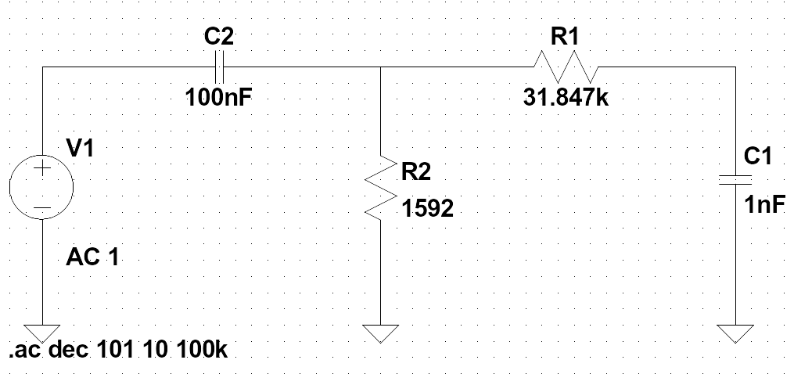Figure 4: Circuit diagram of Experiment 2.

Components and Instruments used:
- A computer: used in the pre-lab to get experiment details from the Moodle
- Resistor kit: contains the resistors to create circuits in the breadboard
- Tektronix PS280 power supply: current source
- Fluke multimeter: used to get measurements such as potential difference, current, etc.
- Breadboard: used to create circuits and connect wires to find values

Procedure:
- Create the circuit shown in Figure 2 on breadboard using the shown resistor values.
- Connect the power supply in constant voltage mode and set the voltage to 9V.
- Set the multimeter to voltage measurement mode and for each resistor, connect the multimeter as parallel to the resistors and measure the voltage drops.
- Set the multimeter to current measurement mode and for each resistor, connect the multimeter as series before or after to the resistor that you want to measure the current passing through.
- Compare the resistor ratios R1, R2, and R3 to potential difference over load R4 and R5. Verify that the potential difference over R3 and 9V is proportional to the R2 and R1.

Results
RESULTS WITHOUT UNITS WILL NOT BE GRADED!
Table 4: Voltage measurements.
A0 | B0 | Cin | S | Cout
0 | 0 | 0
0 | 0 | 1
0 | 1 | 0
0 | 1 | 1
1 | 0 | 0
1 | 0 | 1
1 | 1 | 0
1 | 1 | 1

